Task 2

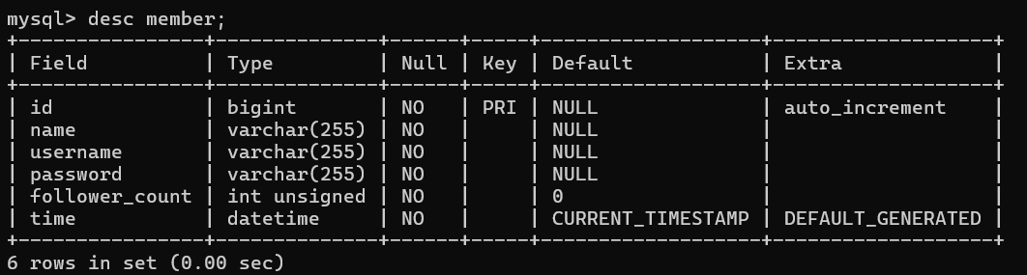

Task 3

r1

r2

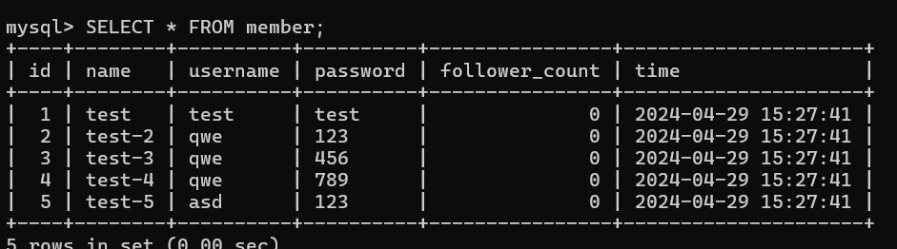

r3

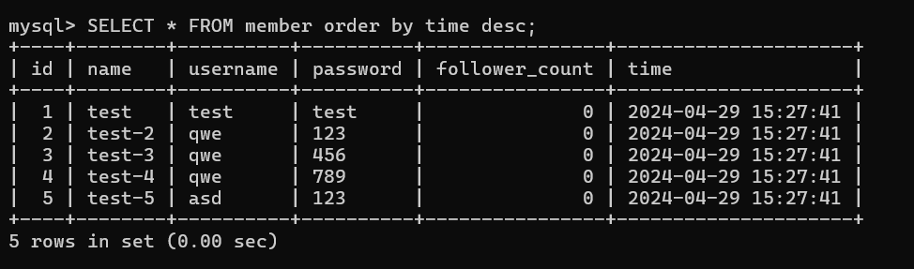

r4

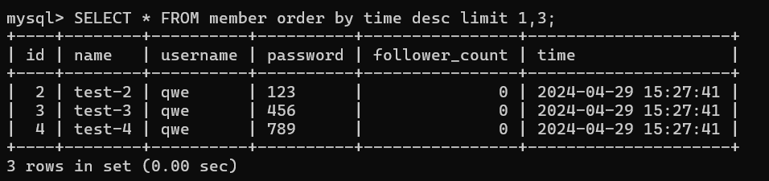

r5

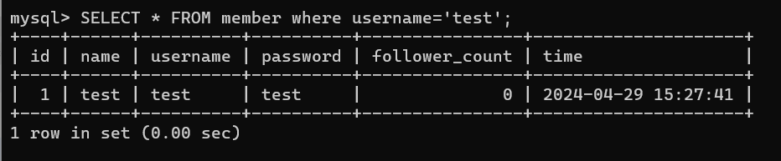

r6

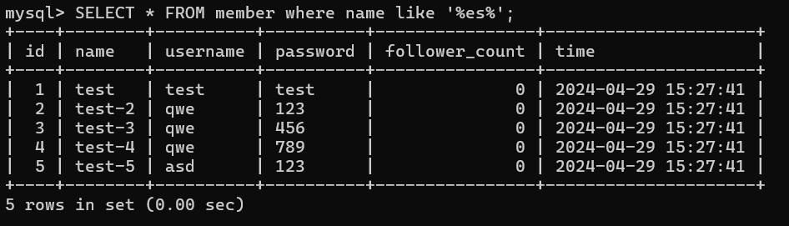

r7

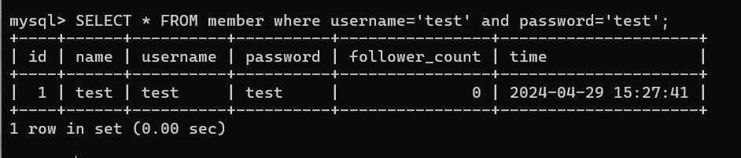

r8

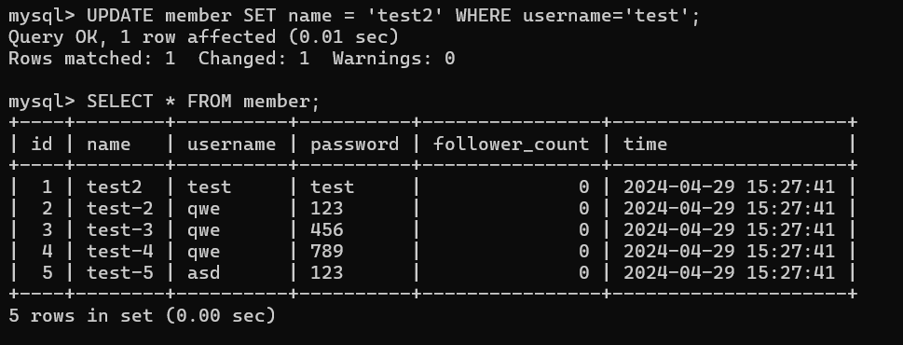

Task4

r1

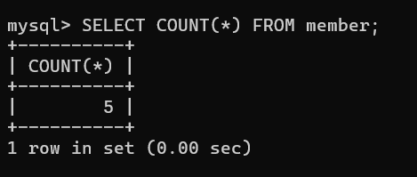

r2

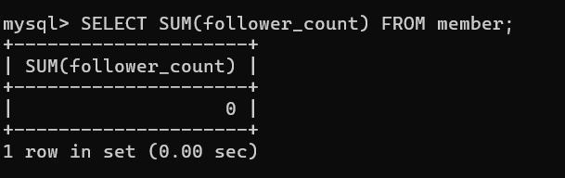

r3

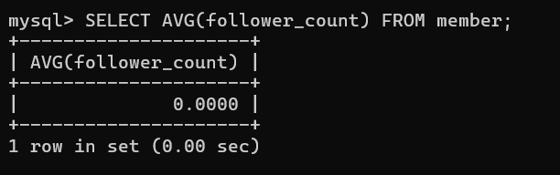

r4

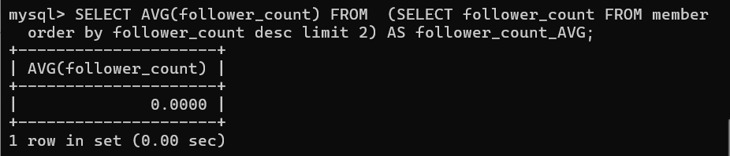

TASK5 r1

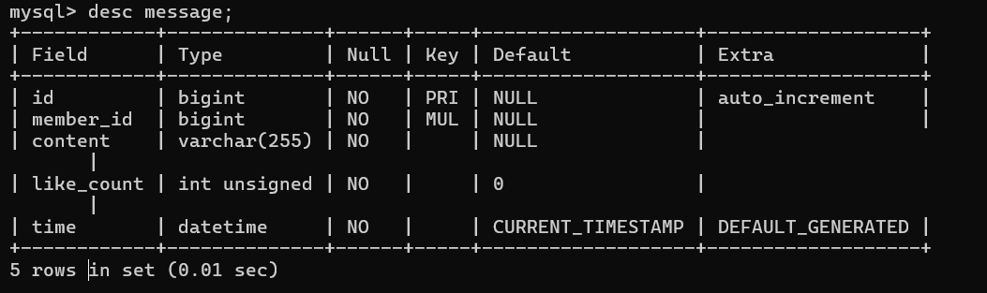

r2

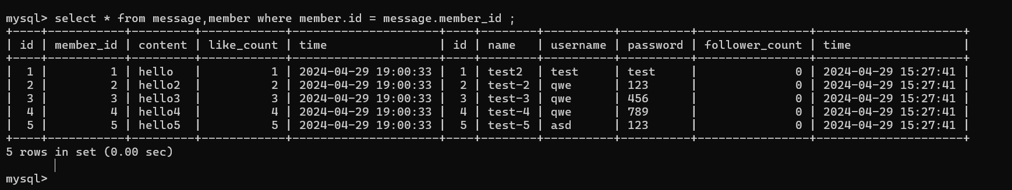

r3

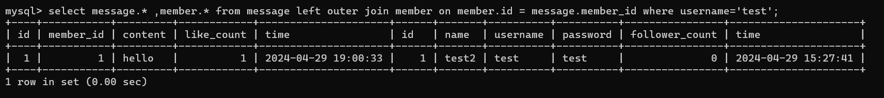

r4

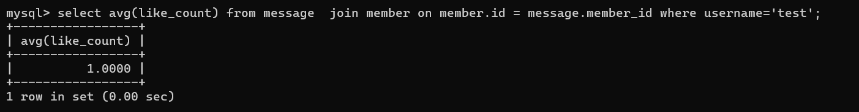

r5

